Instructions for Internet Explorer
Please read these simple, step-by-step instructions, then click on the Get The Origo Root Certificate link below to collect the Origo Root CA certificate onto your PC.
Get the Origo Root CA – G3 certificates

- When prompted by the File Download window that appears after clicking the Get The Origo Root Certificate link above, select the option to Open this file from its current location, and click the OK button.

- A different window will then appear, titled Certificate.
The screenshot below shows the Certificate window details for G3 certificates:
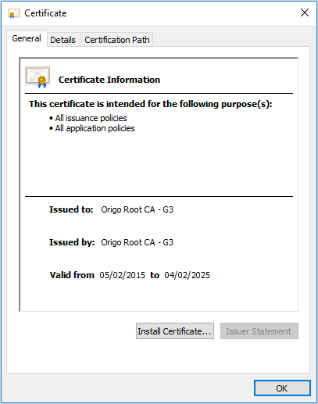
- Click the Install Certificate... button at the bottom of the Certificate window. This will initiate the Certificate Import Wizard.

- Click the Next button on the Certificate Import Wizard's Welcome page to continue.

- When prompted for a Certificate Store for the Origo Root CA, do not select the default 'Automatically select the certificate store' - you must select 'Place all certificates in the following store' and only then click the Browse... button.
- On the Select Certificate Store window, click on Trusted Root Certification Authorities, and then click OK, then click on Next.

- Click on the Finish button on the Completing the Certificate Import Wizard page. You should then see a further window pop up with the message The import was successful, and an OK button. Click on the OK button here to complete the Origo Root CA certificate installation, and then click the OK button on the Certificate window to close it down.

